SHAHZEB 26K-3139
PF POST LAB TASK LAB 5
INSTRUCTOR:SIR SHAYAN
TASK 1
#include<stdio.h>
int main()
{
float temperature;
printf("enter temperature");
scanf("%f",&temperature);
if(temperature <15)
{
printf("cold");
}
else if(temperature >=15 && temperature <=30)
{
printf("normal");
}
else if(temperature >30)
{
printf("hot");
}
}
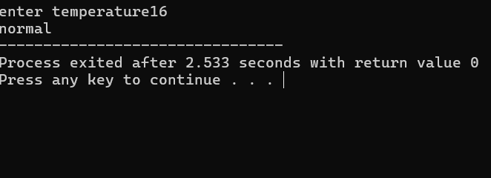

TASK 2
#include<stdio.h>
int main()
{
int balance;
printf("enter balance");
scanf("%d",&balance);
if(balance <500)
{
printf("low balance");
}
else if(balance >=500 && balance <=2000)
{
printf("sufficient balnce");
}
else if(balance >2000)
{
printf("premium balance");
}
}
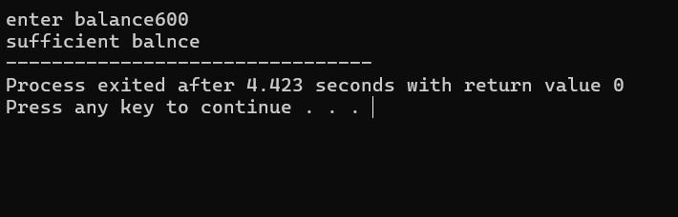
TASK 3
#include<stdio.h>
int main()
{
int appointment,doctoravailable,registrationcompleted;
printf("enter appointment(1 for yes, 0 for no): ");
printf("enter doctoravailable(1 for yes, 0 for no): ");
printf("enter registrationcompleted(1 for yes, 0 for no): ");
scanf("%d",&registrationcompleted);
if(appointment == 1)
{
if(doctoravailable == 1)
{
if(registrationcompleted == 1)
{
printf("patient can meet the doctor");
}
else
{
printf("registration is not completed");
}
}
else
{
printf("doctor is not available");
}
}
else
{
printf("patient has no appointment");
}
return 0;

}
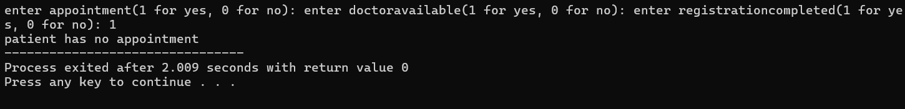
TASK 4
#include<stdio.h>
int main()
{
int resturantopen,itemavailable,balancesufficient;
printf("enter resturantopen(1 for yes, 0 for no): ");
printf("enter itemavailable(1 for yes, 0 for no): ");
printf("enter balancesufficient(1 for yes,0 for no): ");
if(resturantopen == 1)
{
if(itemavailable == 1)
{
if(balancesufficient == 1)
{
printf("itemavailable");
}
else
{
printf("balance is not sufficient");
}
}
else
{
printf("resturant open");
}
}
else
{
printf("item is not available");
}

}
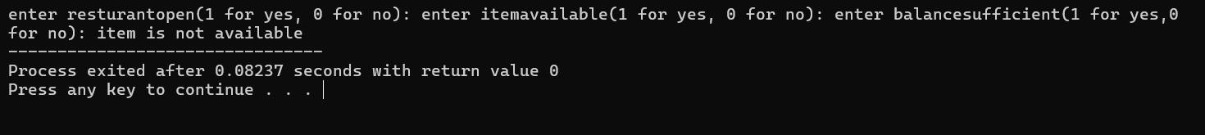
TASK 5
#include <stdio.h>

int main()
{
int operation, account;

printf("1. Balance Inquiry\n");
printf("2. Cash Withdrawal\n");
printf("3. Cash Deposit\n");
printf("4. PIN Change\n");

printf("Enter operation: ");
scanf("%d", &operation);

switch (operation)
{
case 1:
printf("1. Savings Account\n");
printf("2. Current Account\n");
printf("Enter account type: ");
scanf("%d", &account);

switch (account)
{
case 1:
printf("Balance Inquiry - Savings Account");
break;

case 2:
printf("Balance Inquiry - Current Account");
break;

default:
printf("Invalid account type");
}
break;

case 2:
printf("1. Savings Account\n");
printf("2. Current Account\n");
printf("Enter account type: ");
scanf("%d", &account);

switch (account)
{
case 1:
printf("Cash Withdrawal - Savings Account");
break;

case 2:
printf("Cash Withdrawal - Current Account");
break;

default:
printf("Invalid account type");
}
break;

case 3:
printf("1. Savings Account\n");
printf("2. Current Account\n");
printf("Enter account type: ");
scanf("%d", &account);

switch (account)
{
case 1:
printf("Cash Deposit - Savings Account");
break;

case 2:
printf("Cash Deposit - Current Account");
break;

default:
printf("Invalid account type");
}
break;

case 4:
printf("1. Savings Account\n");
printf("2. Current Account\n");
printf("Enter account type: ");
scanf("%d", &account);

switch (account)
{
case 1:
printf("PIN Change - Savings Account");
break;

case 2:
printf("PIN Change - Current Account");
break;

default:
printf("Invalid account type");
}
break;

default:
printf("Invalid operation");
}

return 0;
}
